Testing the Configuration
Activity 1: Test Mandatory Enforcement
- Navigate to Incident:
Go to Incident → Create New to open a new Incident form.
- Set the Impact Field:
Select High for the Impact field. This will trigger the UI Policy and Client Script behaviors you configured earlier.
- Leave Assigned To Empty:
Do not fill in the Assigned To field. This will test the onSubmit Client Script that prevents saving if Assigned To is missing.
- Click Submit:
Attempt to save the Incident record.
- Verify the Result:
  - The Incident should not be saved because Assigned To is required when Impact is High.
  - An error message should appear, indicating that the Assigned To field cannot be empty.
  - Confirm that all UI Policy actions, such as read-only fields or automated urgency updates, are working as expected.

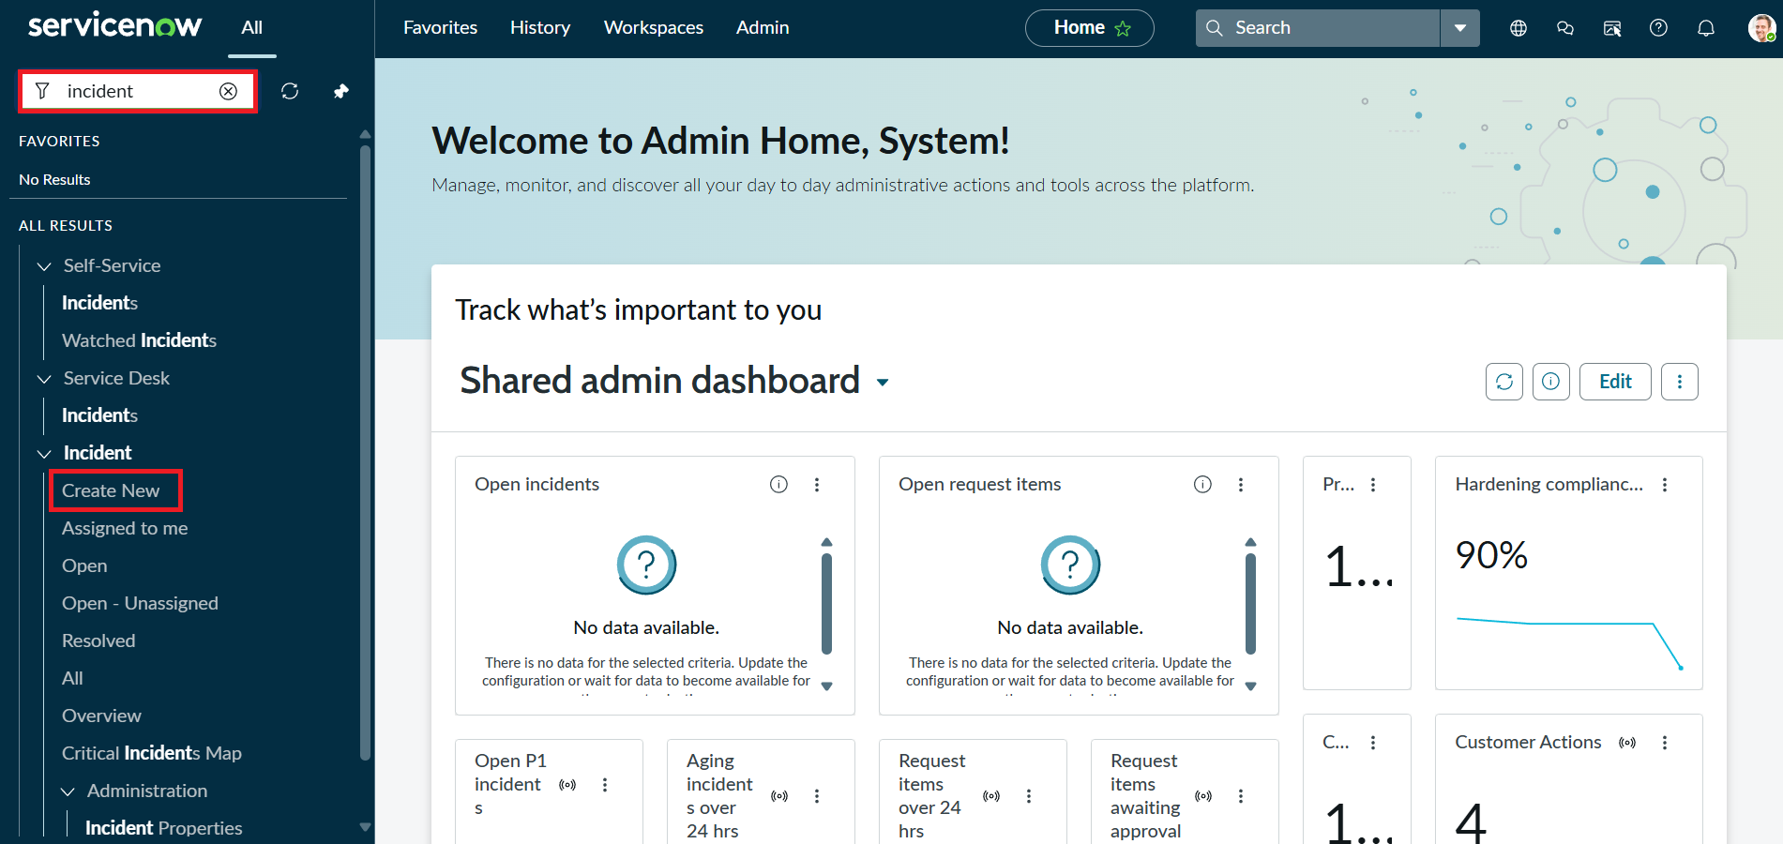
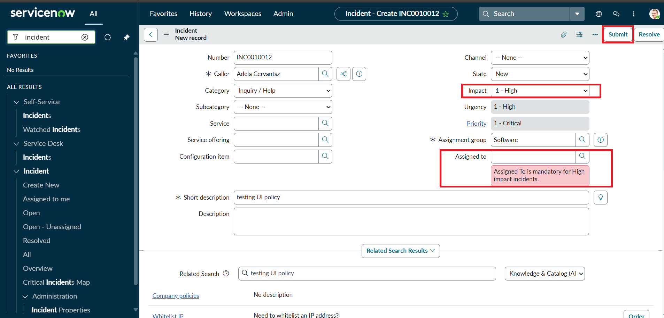
Activity 2: Test Successful Save
- Fill the Assigned To Field:
Open the Incident form and select a user in the Assigned To field. This ensures the onSubmit Client Script condition is satisfied.
- Click Submit:
Attempt to save the Incident record.
- Verify the Result:
  - The Incident should be saved successfully without any errors.
  - Confirm that all other configured behaviors, such as:
    - Urgency auto-setting (from the onChange Client Script)
    - Read-only fields (from the UI Policy Action)
    - State restrictions (from the onCellEdit Client Script)
are functioning as expected
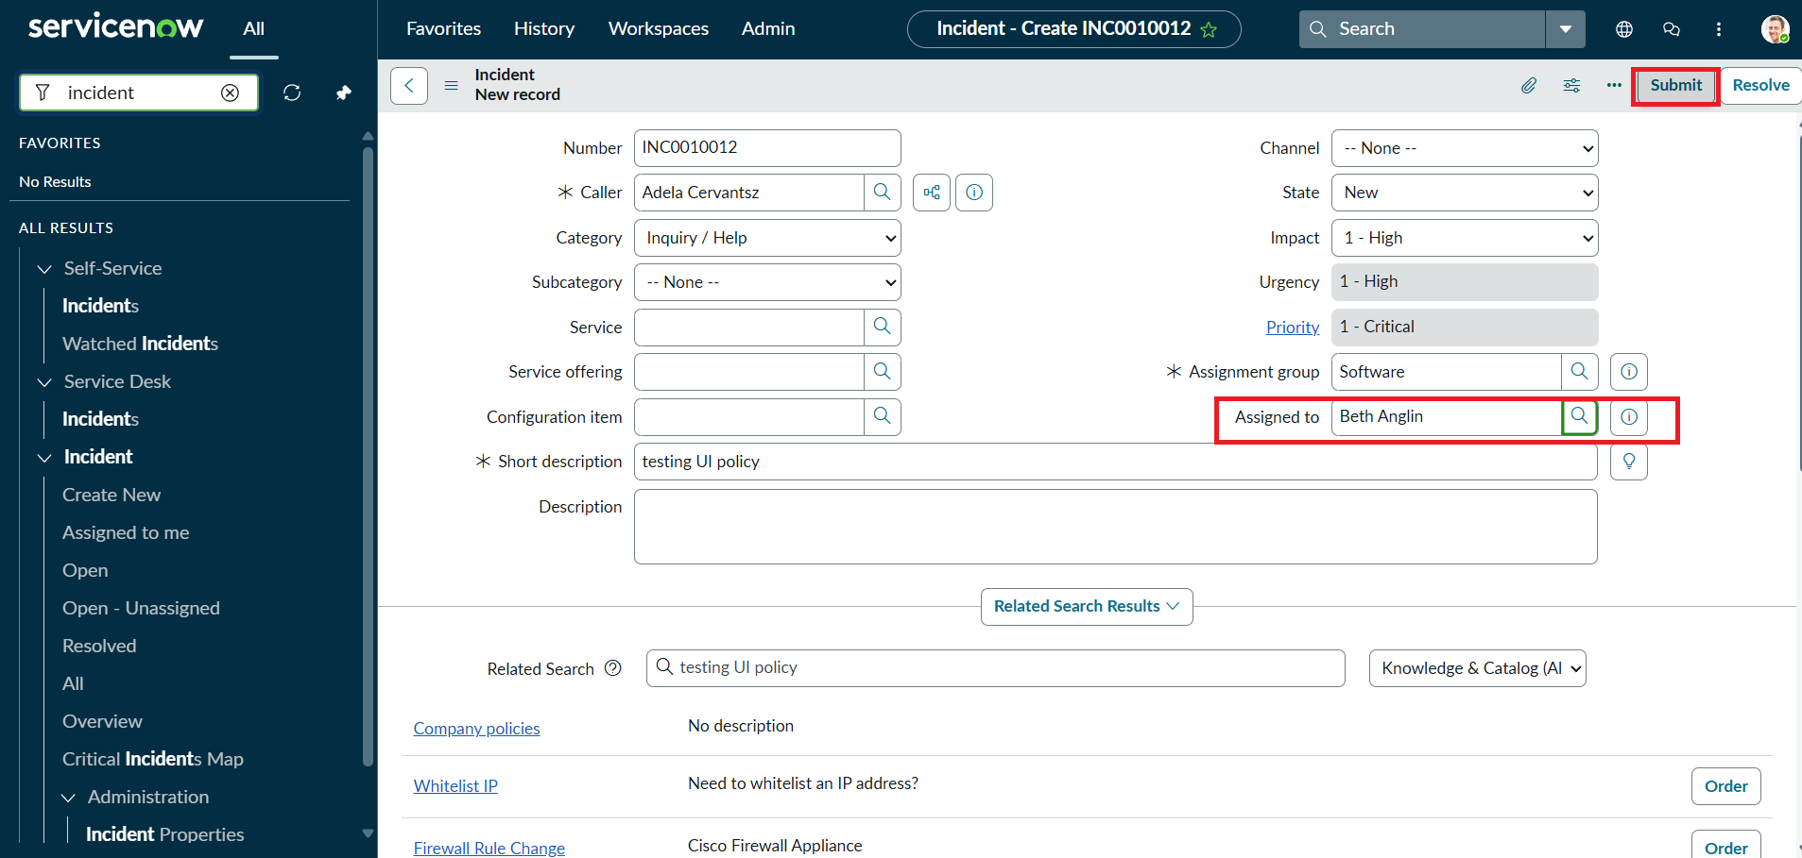

Activity 3: Reverse Condition Test
- Open an Existing Incident:
Go to Incident → Open and select an Incident where Impact is currently set to High.
- Change Impact:
Update the Impact field from High to Medium. This will test the Reverse if false functionality of your UI Policy and the behavior of your Client Scripts.
- Verify the Field Behavior:
  - Assigned To should no longer be mandatory.
  - Urgency should now be editable, meaning the read-only UI Policy action is reversed.
- Save the Record:
Click Submit to save the changes. The record should save successfully without errors, confirming that the reverse condition works as intended.
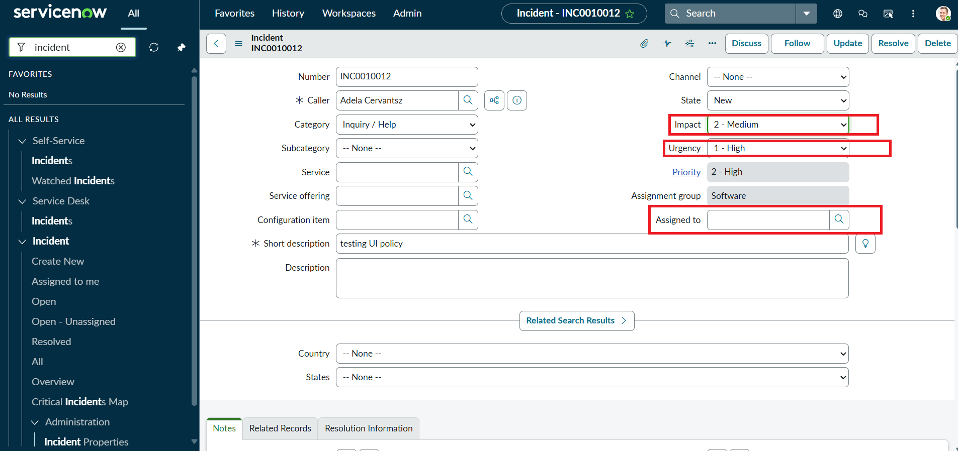

Activity 4: Test List Edit Blocking
- Navigate to the Incident List:
Go to Incident → All to view all Incident records in a list view.
- Attempt a List Edit:
  - Locate any Incident in the list.
  - Double-click the State field to try editing it directly from the list.
- Verify the Behavior:
  - An alert message should appear, indicating that direct changes to the State field are not allowed.
  - The State value should remain unchanged, confirming that the onCellEdit Client Script is working correctly.
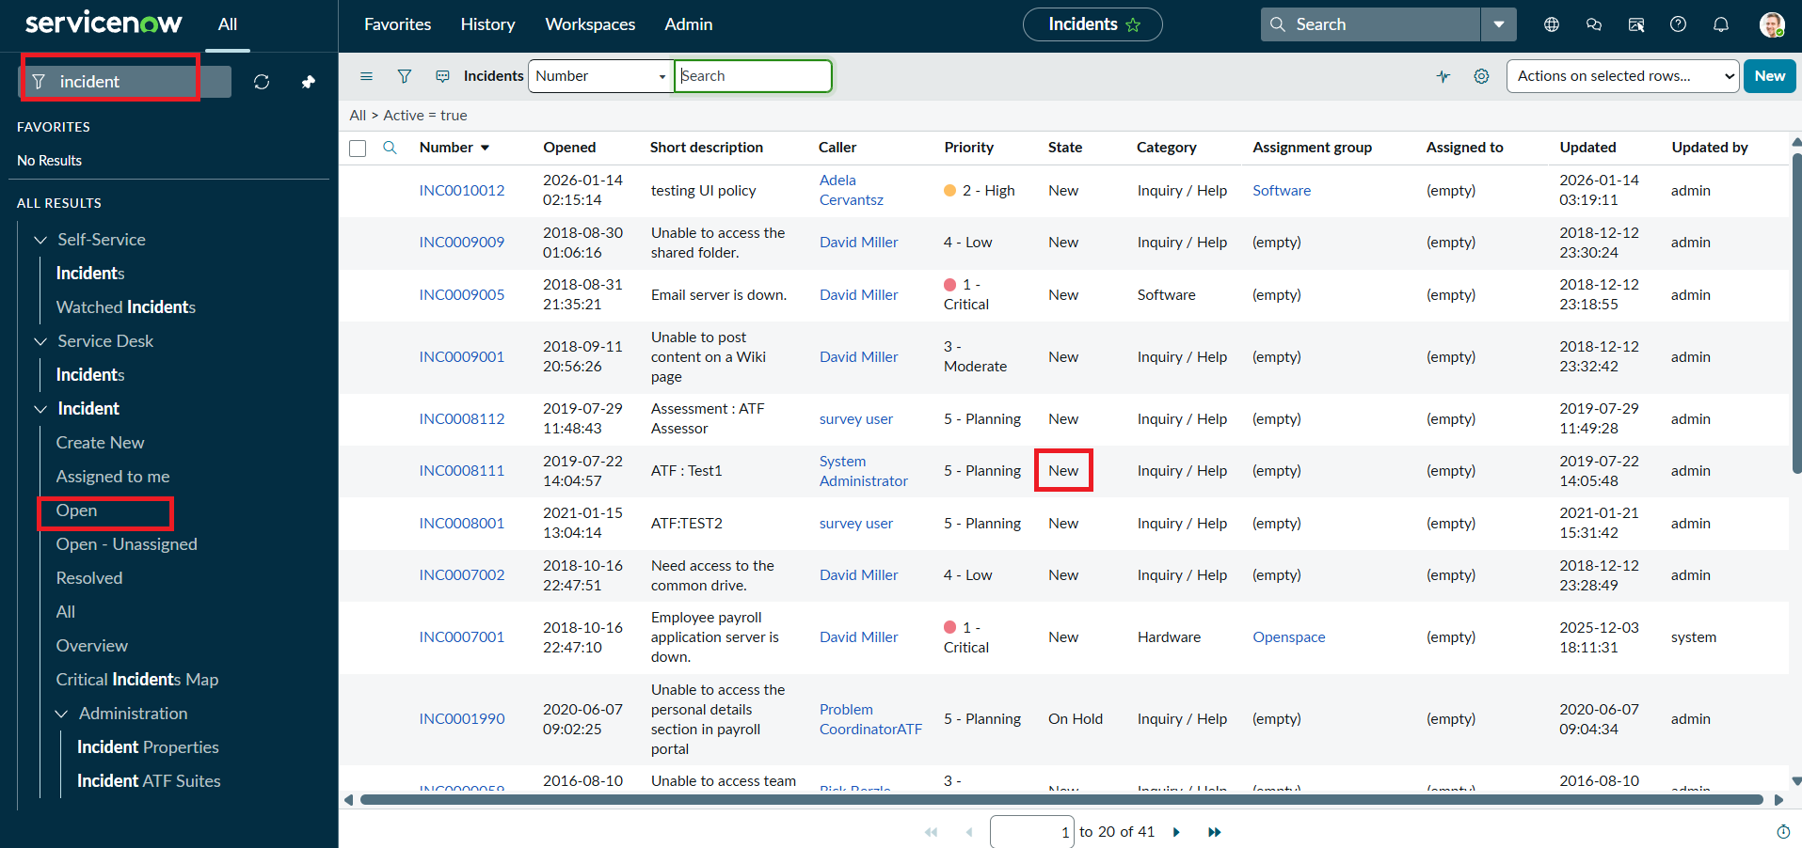

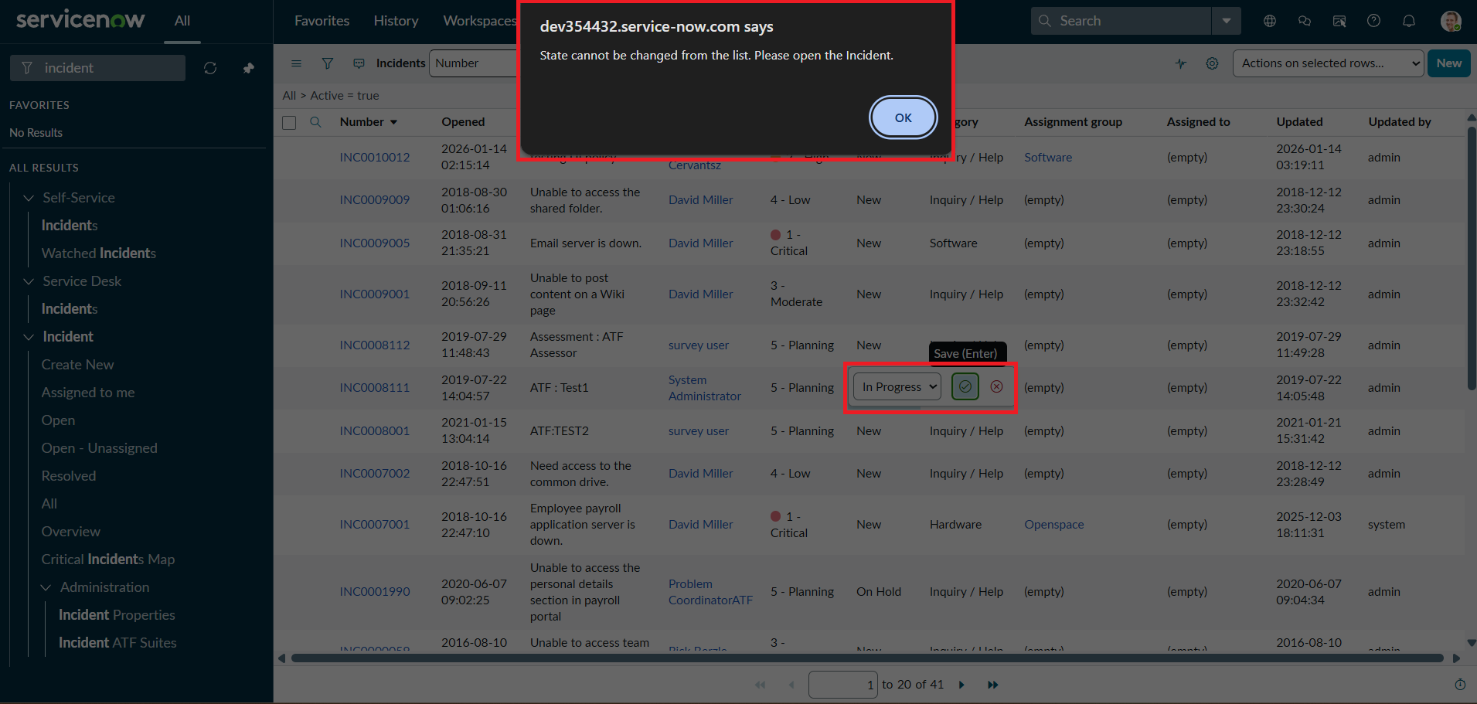

Activity 5: Test Form-Based Update
- Open the Incident Record:
Navigate to the same Incident record you used in previous tests.
- Change the State:
On the Incident form, update the State field to a new value. This tests that changes via the form (not the list) are allowed.
- Click Update:
Save the record by clicking Update.
- Verify the Result:
  - The State change should be saved successfully.
  - Confirm that other fields, such as Assigned To and Urgency, still follow the configured UI Policy and Client Script rules.

